PLEASE NOTE YOU ARE NOT TO CREATE ANY STOCK NUMBERED SAFETY COVERS (ex: SCGM50016311)

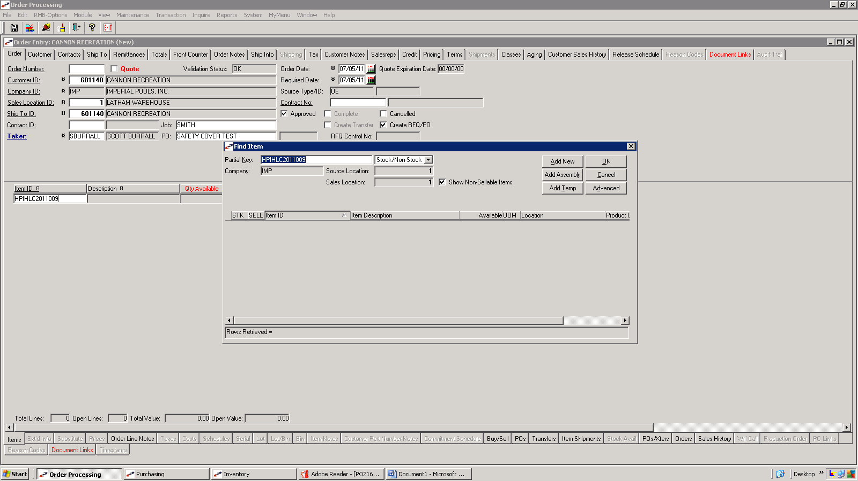

ENTER IN HEADER AS USUAL; GOOD IDEA TO INCLUDE A PO NUMBER (IF DEALER DOES NOT USE A PO ENTER IN JOB NAME INTO PO FIELD AS WELL AS IN THE JOB FIELD)

ENTER IN ITEM ID AND CLICK ‘ADD NEW’

ITEM NUMBERS ARE CREATED AS FOLLOWS; prefix HPI then our quote number (no dashes) EXAMPLE: LATHAM 1ST SAFETY COVER ORDER WOULD BE ‘HPIHLC2013001’

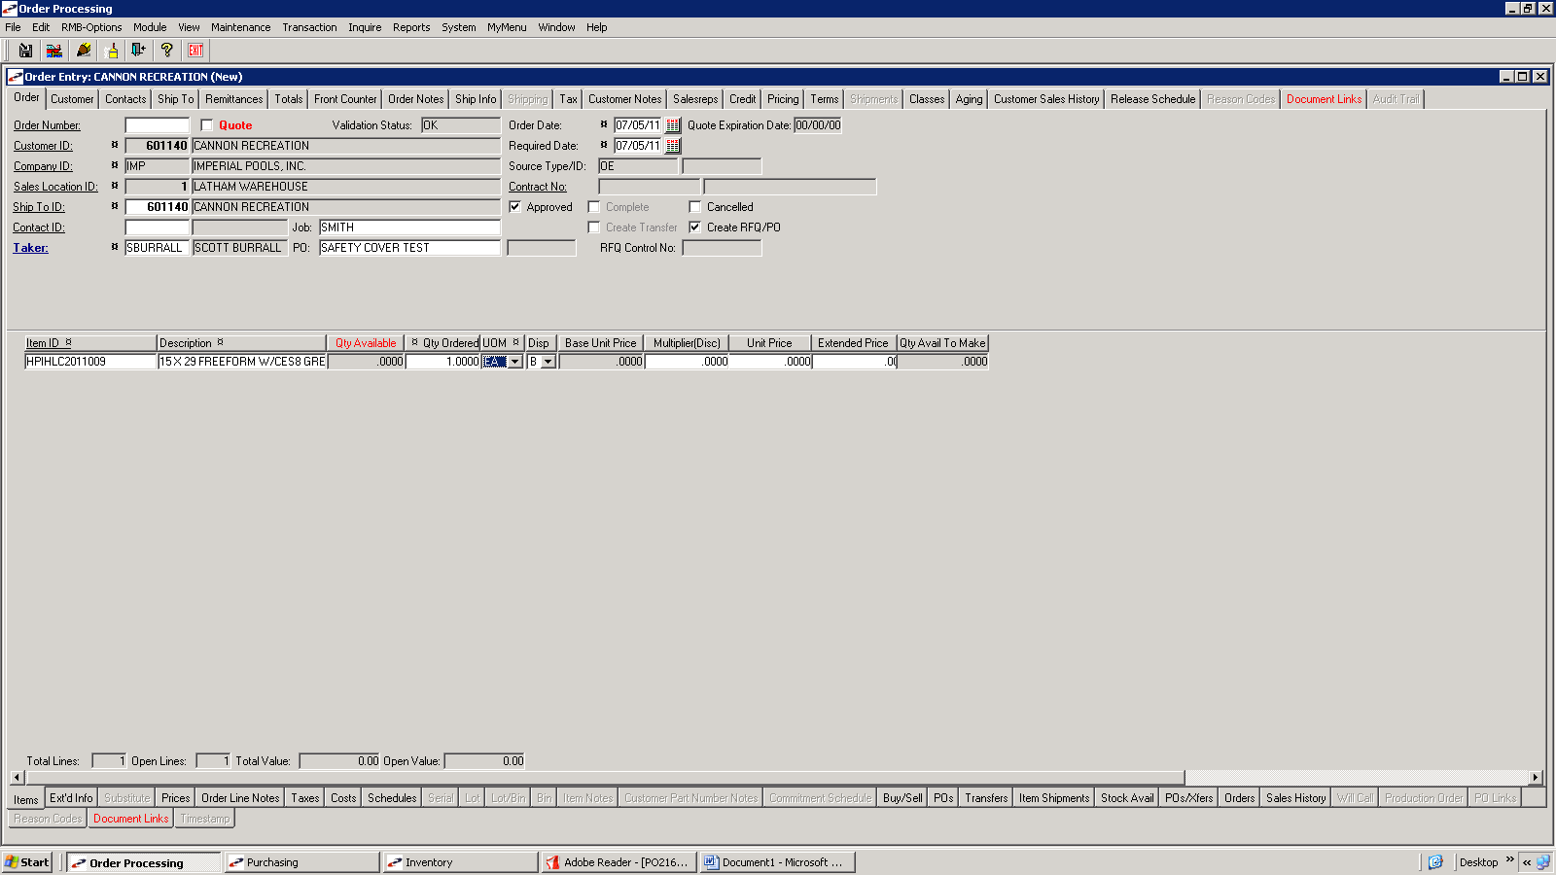

ADD AN ITEM DESCRIPTION (ex: see above, PLEASE INCLUDE SIZE, SHAPE, STEP, COLOR & TYPE)

ENTER 1 AS QTY ORDERED.

NOTICE ‘B’ DISPOSITION

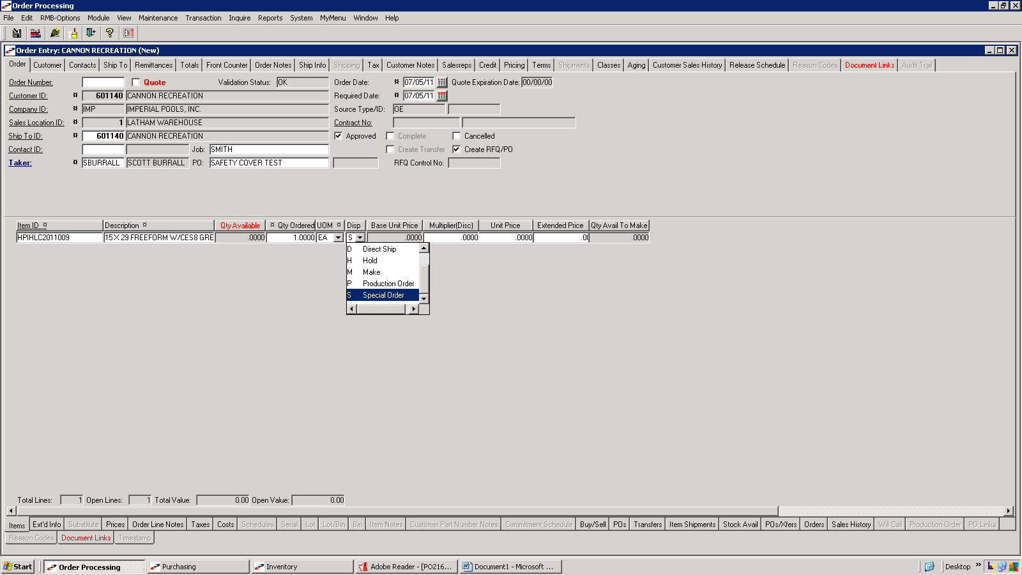

CHANGE DISPOSITION TO SPECIAL ORDER OR DIRECT SHIP

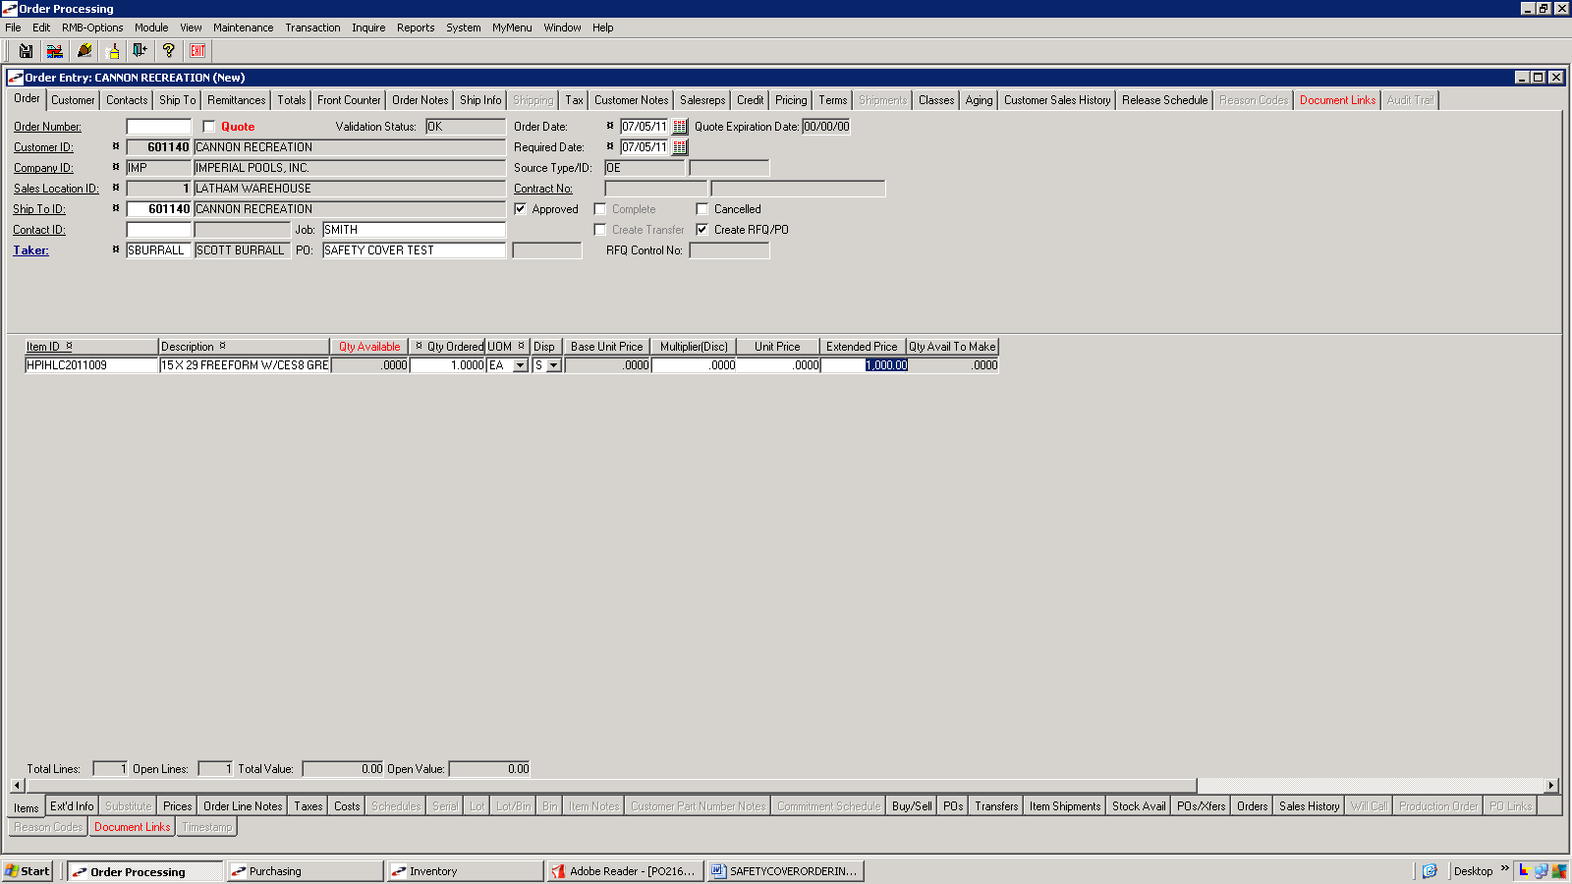

ENTER IN PRICE BEFORE ANY DISCOUNTS IN THE EXTENDED PRICE FIELD

THIS WILL BE FULL DEALER PRICE, MEANING QUOTED LIST PRICE FROM HPI * .73 = DEALER PRICE

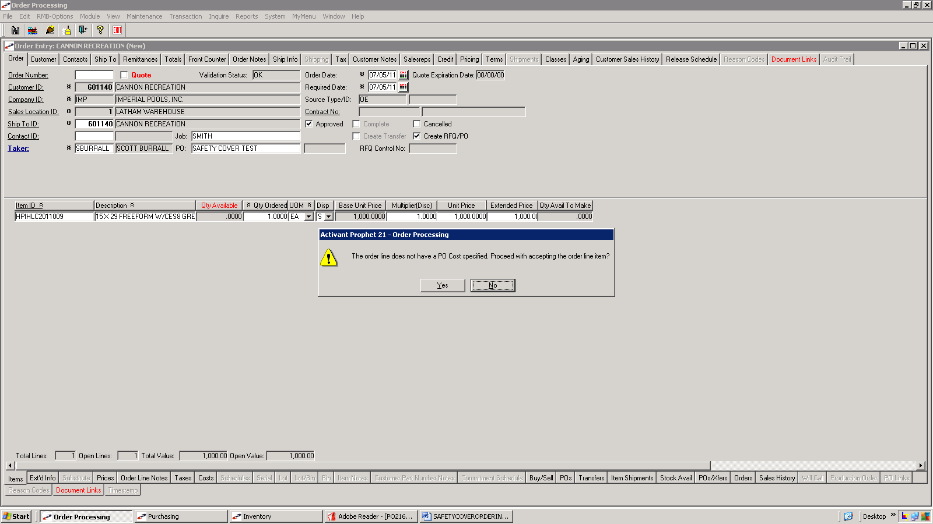

MESSAGE POPS UP ABOUT PO COST

ANSWER NO

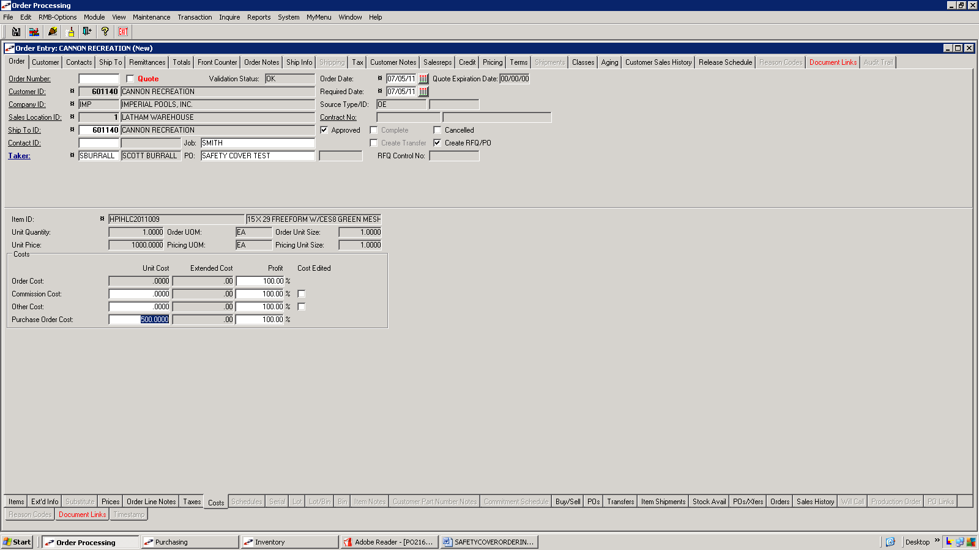

CLICK ON COSTS TAB AND ENTER IN COST IN PURCHASE ORDER COST FIELD

THIS WILL BE HPI LIST PRICE * .415 FOR ALL SPECIALS/CUSTOMS
IF COVER IS A STOCK LEGACY POOL WITH ALTERATION OF STEP, ADDITION OF STEP, CUTOUTS, ETC THEN USE .35 MULTIPLIER.

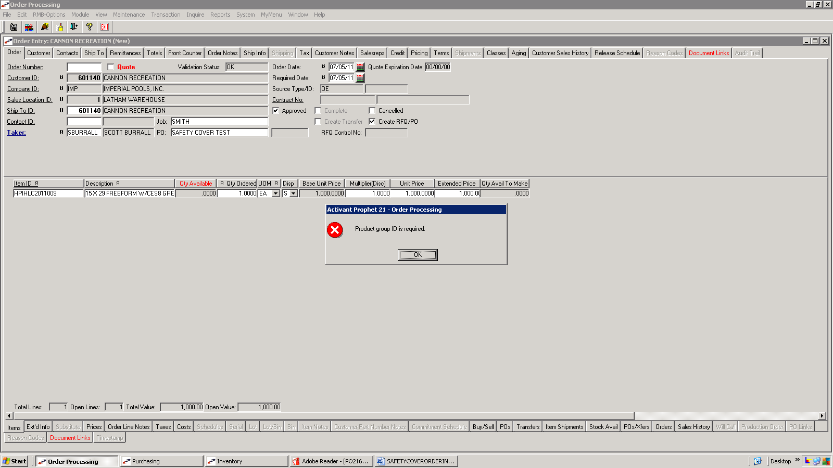

CLICK ON ITEMS TAB, HIT ENTER TO ADD NEW LINE AND MESSAGE APPEARS ABOUT PRODUCT GROUP ID BEFORE YOU ARE ALLOWED TO ENTER IN A NEW LINE.

CLICK OK

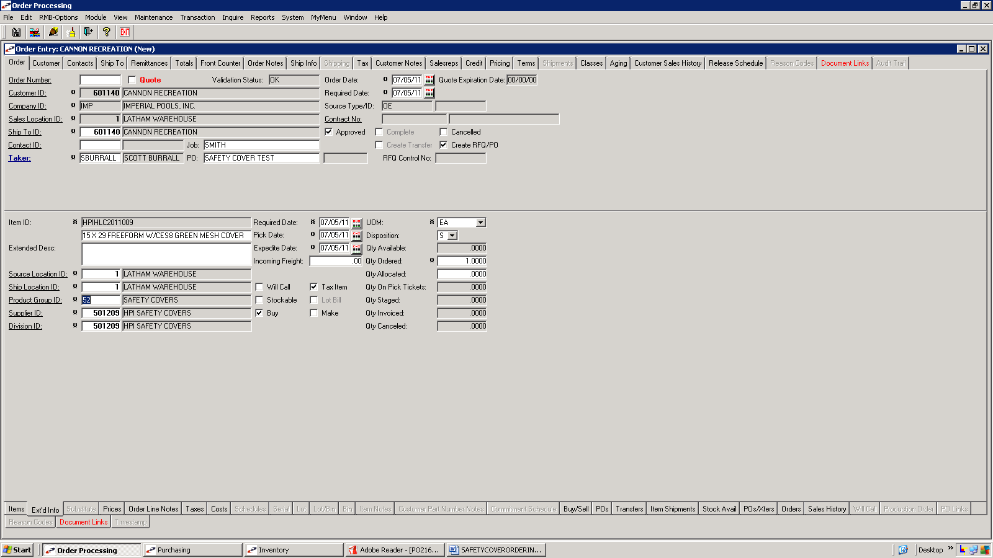

ENTER PRODUCT GROUP ID (ALWAYS 52) AND SUPPLIER ID 501209 FOR HPI SAFETY COVERS

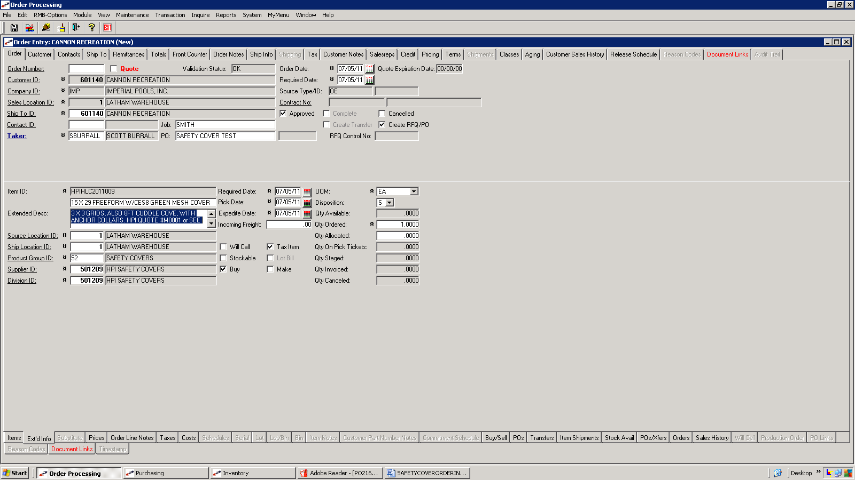

WHILE ON EXT’D INFO TAB ENTER IN EXT’D DESCRIPTION (SHOULD INCLUDE GRID SIZE, CUDDLE COVE, ANCHOR COLLARS, OR ANY OTHER RELEVANT INFORMATION)

THIS MUST INCLUDE HPI QUOTE NUMBER OR SEE DRAWING

WE RECOMMEND PUTTING YOUR PO NUMBER ON ANY DRAWINGS WHEN FAXING TO HPI

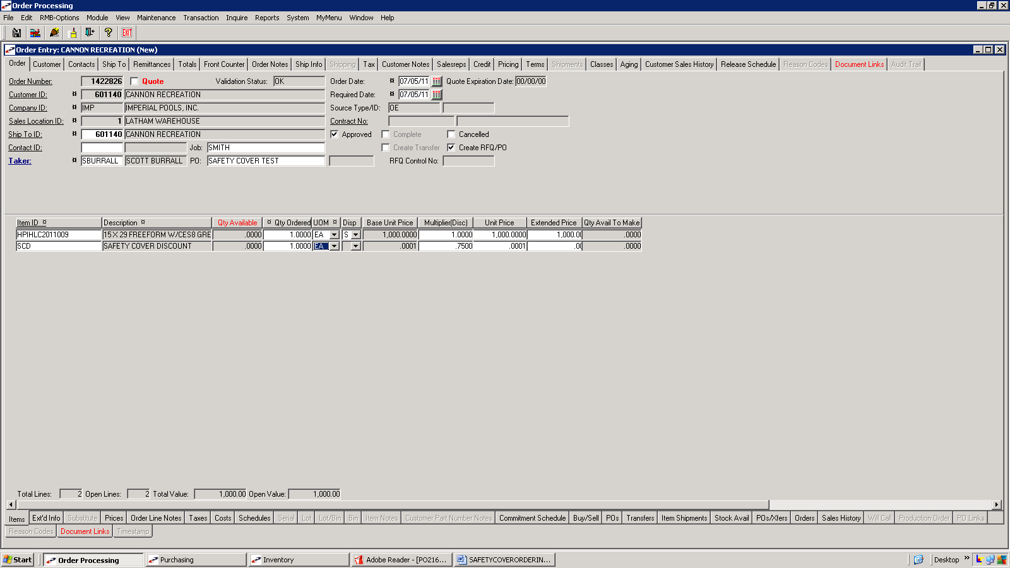

GO BACK TO ITEMS TAB AND ADD 2ND LINE FOR ITEM ‘SCD’

THIS WILL SHOW YOU THE CUSTOMER DISCOUNT

CHANGE THE MULTIPLIER ON THE SAFETY COVER TO MATCH THAT OF THE ITEM ID ‘SCD’.

SYSTEM WILL NOW RECALCULATE THE EXT’D PRICE OF THE SAFETY COVER

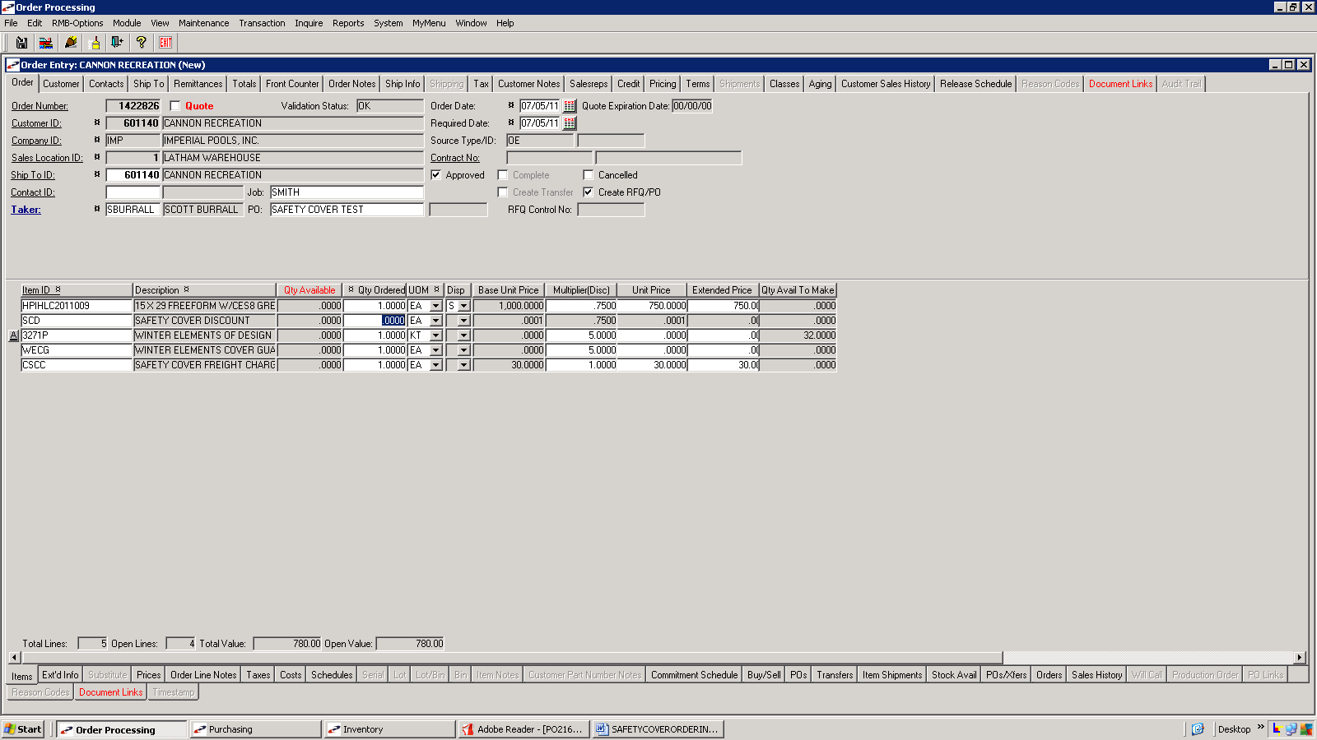

GO TO LINE WITH ‘SCD’ AND ZERO OUT THE QTY ORDERED

CLICK SAVE AND YOU’LL GET MESSAGE ‘UPDATE WAS SUCCESSFUL’

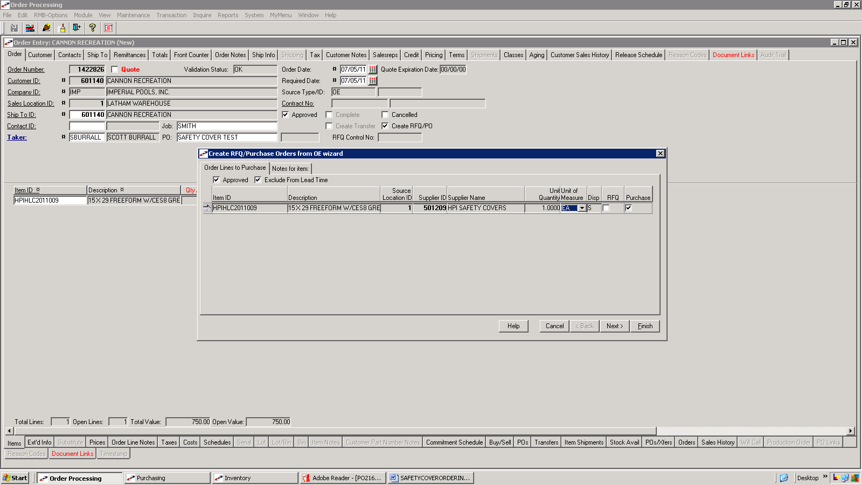

WIZARD POPS UP TO CREATE THE PURCHASE ORDER

NOTE: IF THE ORDER FIRST WENT ON CREDIT HOLD YOU WILL NOT BE PROMPTED WITH THE WIZARD. WHEN THE CREDIT DEPT RELEASES THE ORDER THE BRANCH CONTACT WILL GET AN ALERT. AT THAT POINT YOU WILL HAVE TO GO BACK INTO THE ORDER AND CHANGE THE DISPOSITION BACK TO ‘S’ OR ‘D’. MAKE SURE THE HEADER HAS CREATE RFQ/PO BOX CHECKED.

CLICK SAVE. THE WIZARD SHOULD NOW POP UP.

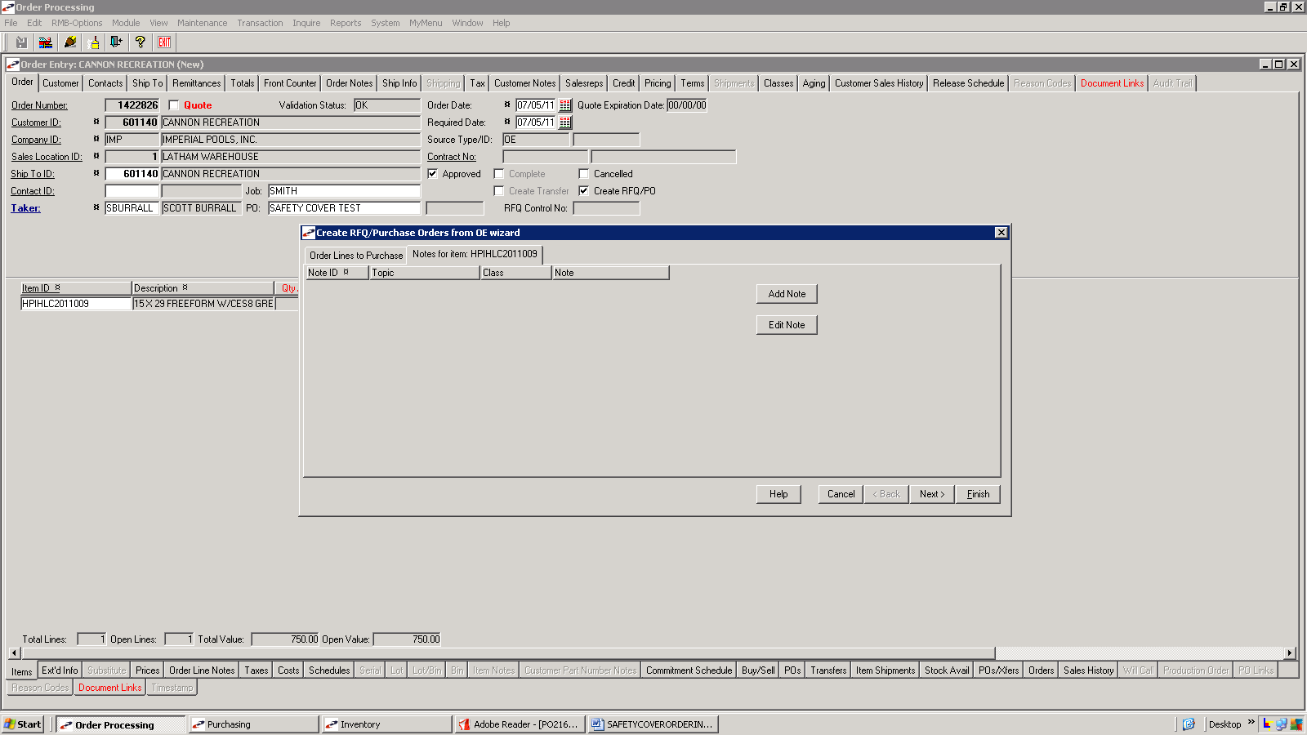

YOU WILL NEED TO ADD A NOTE TO THE ITEM IN THE WIZARD

CLICK THE TAB ‘NOTES FOR ITEM HPIHLC2011009’, THEN CLICK ADD NOTE

THIS IS WHERE YOU WILL TAG COVER WITH DEALER AND CUSTOMER NAMES AS WELL AS ORDER NUMBER.
Example: CYPRESS POOLS/SMITH (1450572)

IMPORTANT AS THIS APPEARS ON BOX LABEL

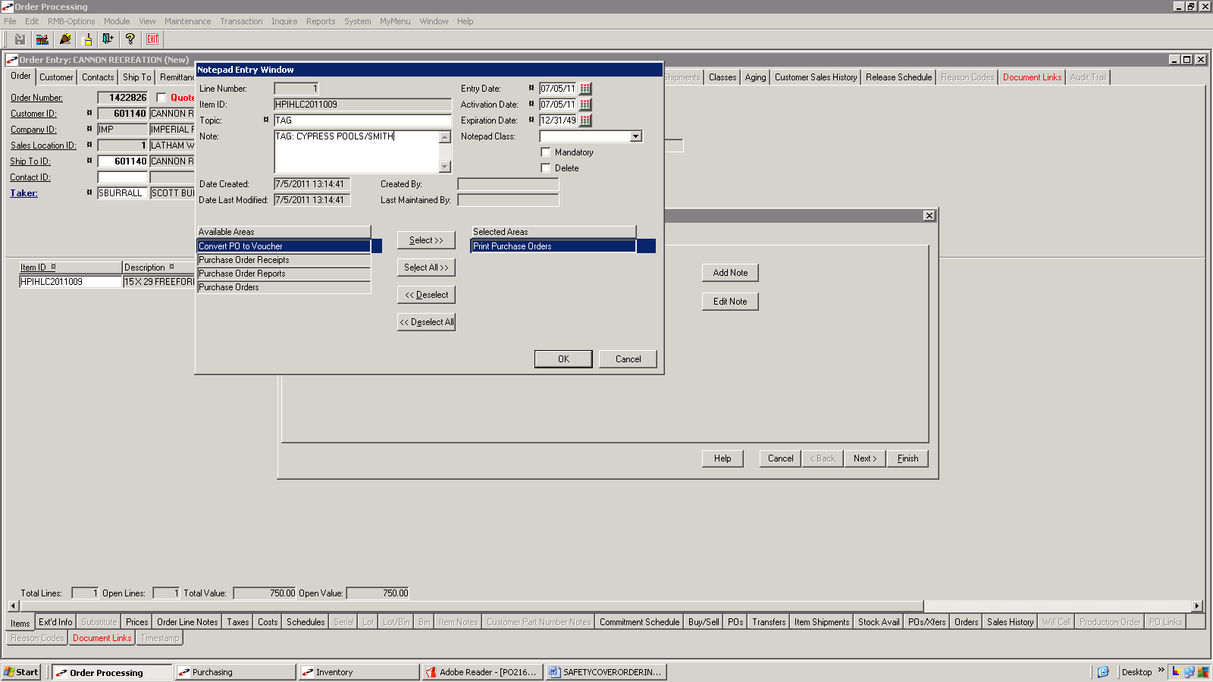

TOPIC = TAG, FILL IN NOTE AREA WITH TAG INFORMATION AND ALWAYS PRINT ON PURCHASE ORDERS

CLICK OK

CLICK NEXT

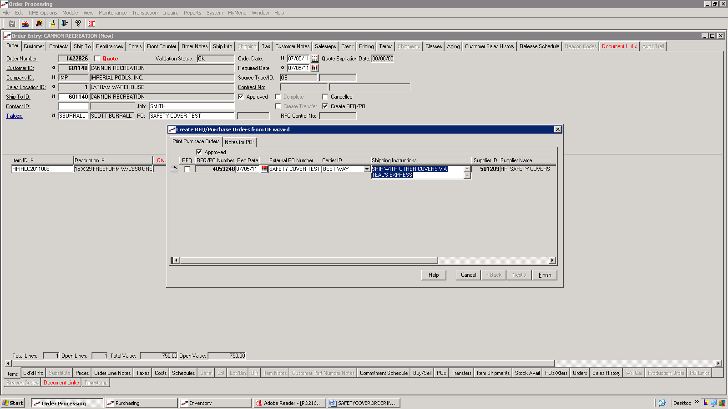

THIS IS WHERE YOU MAY TYPE IN SHIPPING INSTRUCTIONS AND YOU CAN ALSO CHANGE THE REQUIRED DATE TO INCLUDE CURRENT LEAD TIME PLUS SHIPPING

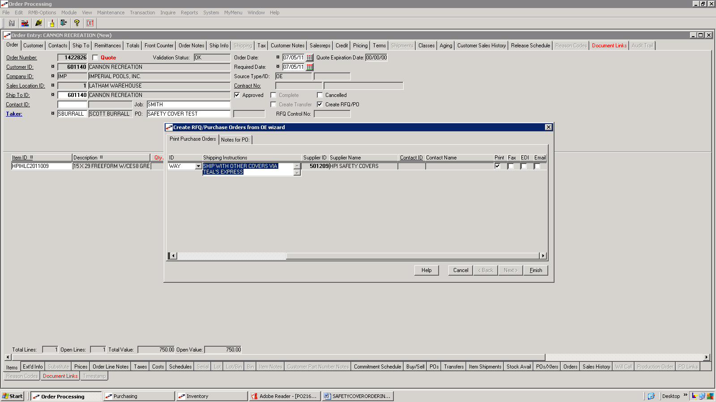

SCROLL TO THE RIGHT AND CHOOSE TO PRINT/FAX/EMAIL THE PO

CLICK FINISH

REMINDER DRAWINGS MUST BE FAXED OR EMAILED TO SUE AT HPI ALONG WITH PO, FAX NUMBER IS 585-798-9249 (this # will come up automatically if fax box is checked). HER EMAIL IS SUE.BUDD@HINSPERGERS.COM.

WHEN YOU RECEIVE CONFIRMATION FORWARD COPY OF EMAIL TO MANFRED (MJESCHKE@IMPERIALPOOLS.COM)

PLEASE VERIFY THE INFORMATION ON YOUR CONFIRMATION. IT MUST BE THOROUGHLY CHECKED FOR SHIPPING LOCATION, PO NUMBER, TAG NAME, COST, DESCRIPTION (especially color and material) AND POOL SIZE AND STYLE.

YOU SHOULD PUT AN ORDER NOTE OF THE CONFIRMATION DATE ON YOUR CUSTOMER SALES ORDER IN P21. THIS WILL HELP WITH THE GUARANTEED 10 DAY LEAD TIME POLICY.

